**International Islamic University Chittagong**

**Department of Computer Science and Engineering**



**A Project Proposal on**

Decentralized Social Network using Blockchain (Link-din)

**Supervised by**

Mr. Sazid Zaman Khan .

Lecturer,

Department Of CSE,IIUC .

Email: [sazidszk2020@gmail.com](mailto:sazidszk2020@gmail.com)

Mobile Number :01770346336

**Submitted by**

Name **:**Jamshedul Alam

Id : C171029

Email**:** [engrjamshedulalam@gmail.com](mailto:engrjamshedulalam@gmail.com)

Mobile Number **:** 01858043037

Name:Mohammed Raihan

Id : C163069

Email : [mdraihan4835@gmail.com](mailto:mdraihan4835@gmail.com)

Mobile Number : 01855065201

**Approval of the Supervisor**

______________________

**Mr.Sazid Zaman Khan**

Lecturer, Department Of CSE,IIUC .

**2. Introduction**

Online Social Networks have become extremely popular , where users can share photos , videos, and information with their friends .As a Example , Facebook already has more than two billion users. At the same time , the privacy of users is found to be easily be compromised in Online Social Network(OSN). Although Online Social Network(OSN) allow users to adjust privacy settings to limit who can access and who can’t . In this situation we don’t have any good technical solutions to provide access or prevent them from providing user’s data to third party. In March 2018, The New York times reported that a company illegally obtained information of more than 50 million users on Facebook [1]. The major reason of these incidents is that the existing OSNs with central structure can fully grasp all users information .The Solution is BlockChain based decentralized Online Social Network(OSN).

**3. Problem Statement**

When we upload a content in a OSN we feel insecure that what if we are hacked or being blocked and we lost control of our OSN account .The biggest Question comes to our mind is how can we make our data secure ? Rather Giving OSN the main copy of data , what if we have a system where we store data and we only give a permitted hash value to OSN system ?

**4 .Literature Review /Review of the Existing Works**

A)SocialX

1. **Features/Function of the Project**

* User Registration AND user Login
* User can Post text , Share Video, Share Image.
* Other User can Like , dislike in other’s post .
* User can comment’s on other’s Post.

**6. Aims / Objectives**

The aim of this Social Network is that ., it will Protect a OSN user from getting hacked and losing the personal data shared in OSN platform.

The specific objectives includes:

* To Protect user Account.
* To keep the access of personal data safest.
* To keep every resources in a separate cloud storage , to which the OSN will talk to get the specific data using users permissions and public key.
* To motivate users to share content and prevent malicious users. Users who share high-quality content can get rewarded with likes and comments and Will be shown in feed-front in OSN .
* we used Blockchain to protect the public keys of users in OSN. These public keys are used to verify the identities of users and to resist the attacks from malicious users.

**7. Methodology / Approach / Strategy**

This Project is a D apps. It will Decentralize the data control in Distributed OSN system.

When A user will register in D Apps , he also connect his IPFS account with his account of OSN . It will create handshake between IPFS and OSN system. They will talk to each other and OSN only get a hash value of data for accessing the data given by User.

By this process we create a secure data storage which are decentralize data storage .User can Up-vote ones post and give cryptocurrency as reward of the Quality Content shared by the user. User can also interact with others by using cryptocurrency to build a secure relationship with others.

Here is the diagram of Spiral model for the software process model.

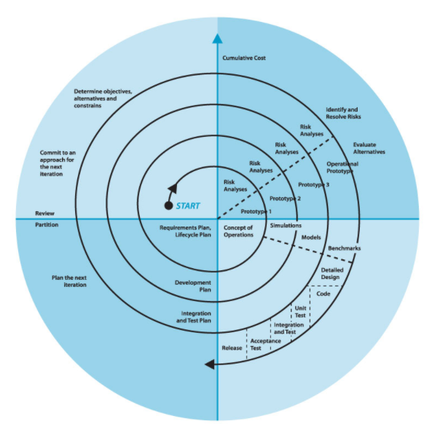

**7.2 . Frontend tools and technics**

React Js , Rest API , Material UI.

**7.3 . Backend tools and technics**

Web3.js , Laravel , PhpMyAdmin , solidity

**7.4 Flow of Activities for the Proposed Project**

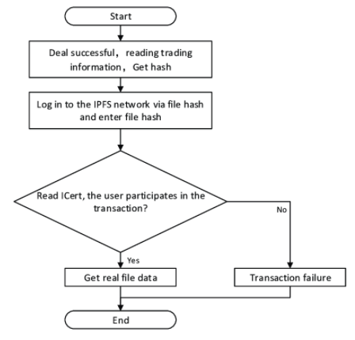

1. **Expected Outcomes from the Proposed Project**

We hope a excellent project from our site . We are optimistic to make a strong and optimized project .As we are implementing blockchain , it though little tough but we expect to make a working project with large user.

**8. Expected Thesis/Project contribution**

As we all use OSN Link-din , we are not safe here . If any of us are affected by the malicious user and get hacked , we will loss all our data and everything we share in Link-din. In this Project We trying to reduce risk of Link-din user by Implementing IPFS blockchain to the system. It will change how we interact with friends and data Security.

**10. The Importance and Benefits of the Thesis/Project to the Industry or Society:**

Now Blockchain is growing day by day . People are searching for a way to make their data secure and Blockchain comes to in the scenario to solve the biggest problem . Technology are coming to solve people’s problem so that we can make this world a better place.

**11. Gantt Chart of Thesis/Project Activities**

|  |  |  |  |  |  |  |  |  |
| --- | --- | --- | --- | --- | --- | --- | --- | --- |
|  | March | April | June | July | August | September | October | November |
| Registration |  |  |  |  |  |  |  |  |
| Project selection |  |  |  |  |  |  |  |  |
| Planing |  |  |  |  |  |  |  |  |
| Feasibility Study |  |  |  |  |  |  |  |  |
| System Design |  |  |  |  |  |  |  |  |
| Implementation |  |  |  |  |  |  |  |  |
| Testing |  |  |  |  |  |  |  |  |
| Submission |  |  |  |  |  |  |  |  |

**12. Budget**

**13. Reference list or bibliography**

[1] . How Trump Consultants Exploited the Facebook Data of Millions.  
Accessed: May 5, 2018. [Online]. Available: https://www.nytimes.com/  
2018/03/17/us/politics/cambridge-analytica-trump-campaign.html